 **GEOGRAPHICAL ASSOCIATION OF WESTERN AUSTRALIA** [Inc.]

**GEOGRAPHY – Year 11 ATAR Unit 2 Examination**

**Semester 2, 2018**

**Question/Answer Booklet**

**Student Name:** ________________________________________

**Student Number:**

(if required)

**Teacher Name:** ________________________________________

**Time allowed for this paper**

Reading time before commencing work: ten minutes

Working time: three hours

**Materials required/recommended for this paper**

***To be provided by your teacher/supervisor***

This Question/Answer Booklet

Broadsheet

Multiple-choice Answer Sheet

Examination writing booklet/paper

***To be provided by candidate***

Standard items: pens (blue/black preferred), eraser, correction fluid/tape, highlighters ruler, pencils (including coloured), sharpener,

Special items: approved drawing and measuring instruments (i.e. dividers, drawing compass, string, protractor), non-programmable calculators approved for use in the WACE examinations.

**Important note to candidates**

No other items may be taken into the examination room. It is **your** responsibility to ensure that you do not have any unauthorised materials. If you have any unauthorised material with you, hand it to your teacher/supervisor **before** reading any further.

**Structure of this paper**

|  |  |  |  |  |  |
| --- | --- | --- | --- | --- | --- |
| **Section** | **Number of questions available** | **Number of questions to be answered** | **Suggested working time**  **(minutes)** | **Marks available** | **Percentage**  **of**  **examination** |
| Section One:  Multiple-choice | 20 | 20 | 30 | 20 | 20 |
| Section Two:  Short response | 10 | 10 | 70 | 40 | 40 |
| Section Three Extended response  Part A: Depth Study 1 | 2 | 1 | 40 | 20 | 20 |
| Section Three  Extended response  Part B: Depth Study 2 | 2 | 1 | 40 | 20 | 20 |
| **Total marks** | | | | | **100** |

**Instructions to candidates**

1. The rules for the conduct of this examination are as detailed by your teacher/supervisor.Sitting this examination implies that you agree to abide by these rules.

2. Answer the questions according to the following instructions:

Section One: Answer **all** questions on the separate Multiple-choice Answer Sheet provided. For each question, shade the box to indicate your answer. Use only a blue or black pen to shade the boxes. If you make a mistake, place a cross through that square, then shade your new answer. Do not erase or use correction fluid/tape. Marks will not be deducted for incorrect answers. No marks will be given if more than one answer is completed for any question.

Section Two: Answer all questions in the spaces provided in this Question/Answer booklet.

Section Three:

Part A: Answer one question from a choice of two.

Part B: Answer one question from a choice of two.

Write your answers in this Question/Answer Booklet or the writing booklet/paper provided by your teacher/supervisor.

3. Wherever possible, you are encouraged to use **relevant, fully-labelled sketch maps, diagrams and actual examples** to illustrate, and support your answers.

4. You must be careful to confine your responses to the specific questions asked and to follow any instructions that are specific to a particular question.

5. Additional working space pages for planning or continuing an answer are provided at the end of this Question/Answer booklet or provided by your teacher/supervisor. If you use these pages, indicate at the original answer, the page number it is planned/continued on and write the question number being planned/continued on the additional working space page.

1. You are encouraged to refer to the **sources on the Broadsheet** to support your answer **for any question**.

**Section One: Multiple-choice 20% [20 marks]**

This section has **twenty (20)** questions. Answer **all** questions on the separate Multiple-choice Answer Sheet provided. For each question, shade the box to indicate your answer. Use only a blue or black pen to shade the boxes. If you make a mistake, place a cross through the square, then shade your new answer. Do not erase or use correction fluid/tape. Marks will not be deducted for incorrect answers. No marks will be given if more than one answer is completed for any question.

Suggested working time for this section is 30 minutes.

**Note: GR = Grid Reference, AR = Area Reference.**

____________________________________________________________________________

Refer to **Source 1** Launceston topographic map to answer Questions 1 to 9.

1. The contour interval for the topographic map is
2. 5 metres.
3. 10 metres.
4. 20 metres.
5. 40 metres.
6. Which one of the following Area References would contain the steepest area of land?
7. AR 0312
8. AR 0511
9. AR 0715
10. AR 0911
11. The latitude and longitude of Ti Tree Bend at GR 098147 is closest to
12. 41° 15’ S 147° 10’ E.
13. 41° 25’ S 147° 07’ E.
14. 147° 10’ S 41° 15’ E.
15. 147° 07’ S 41° 25’ E.
16. The map scale for the Launceston topographic map as a statement in words is
17. one centimetre represents 2.5 metres.
18. one centimetre represents 25 metres.
19. one centimetre represents 250 metres.
20. one centimetre represents 250 kilometres.
21. One minute of latitude as represented on this map is closest to a distance of
22. 1 kilometre.
23. 2 kilometres.
24. 3 kilometres.
25. 4 kilometres.
26. The type of hydrological feature found at GR 105131 is a

(a) beach

(b) saline coastal flat

(c) tidal flat

(d) tidal reef

1. The landform feature located in the northeast corner of the grid square AR 0311 is a
2. cliff.
3. locality boundary.
4. mountain.
5. spur.
6. The two types of features on the map which show the strongest positive correlation in terms of their spatial association are
7. flat land and sporting facilities.
8. flat land and vegetated areas.
9. steep land and highways.
10. steep land and timber plantations.
11. Which one of the following compass bearings would be closest to your general direction of travel if you were travelling from the Launceston city centre (AR 1112) to the suburb of Riverside (AR 0815)?
12. 45 degrees
13. 135 degrees
14. 225 degrees
15. 315 degrees

Refer to **Source 1** Launceston topographic map and **Source 2** Launceston satellite image to answer Questions 10 to 12.

1. The distance along West Tamar Road (Route A7) from the Rowing Club (GR 106126) to the edge of the Launceston satellite image, travelling in a NNW direction is closest to
2. 160 metres.
3. 260 metres.
4. 1600 metres.
5. 2600 metres.
6. The cultural feature located at GR 114120 on **Source 1** is a
7. park.
8. sewage plant.
9. sports ground.
10. swimming pool.
11. Which one of the following statements is correct?
12. The scale of the satellite image is larger than that of the topographic map.
13. The scales of the satellite image and the topographic map are the same.
14. The scale of the topographic map is larger than that of the satellite image.
15. The scale of the topographic map is twice as large as that of the satellite image.

Refer to **Source 1** Launceston topographic map, **Source 2** Launceston satellite image and **Source 3** Ground photograph to answer Question 13.

1. The ground photograph in **Source 3** was taken at approximately GR 111133. Based on evidence from the sources, which direction was the photographer facing when taking the photograph?
2. To the north, northeast.
3. To the north, northwest.
4. To the south, southeast.
5. To the south, southwest.
6. The term international integration refers to
7. significant and enduring changes to the nature and structure of an economy.
8. the arrangement of geographical phenomena or activities across the Earth’s surface.
9. the changing relationship between economic and cultural entities leading to an erosion of their autonomy and uniqueness.
10. the relationship between the distribution patterns of different phenomena on the Earth’s surface.
11. The increasing integration of the different cultures found throughout the world and the diffusion of a dominant global culture is known as
12. cultural internationalisation.
13. cultural inertia.
14. economic integration.
15. economic restructuring.

Refer to **Source 7** 2018: This is what happens in an internet minute to answer Question 16.

1. According to **Source 7**, the four internet applications which facilitate the greatest number of average interactions in a minute are
2. emails, tinder, text messages and Google searches.
3. emails, messages, text messages and YouTube videos.
4. Facebook logins, Twitch views, tweets sent and apps downloaded.
5. Google searches, snaps created, text messages and tweets sent.

Refer to **Source 8** Global city power index to answer Questions 17 and 18.

1. The measure of global city power with the highest overall ranking in the top ten cities is
2. accessibility.
3. cultural interaction.
4. liveability.
5. research and development.
6. The arithmetic mean for the measure, liveability, for the top ten cities is
7. 12.1.
8. 13.8.
9. 15.9.
10. 16.1.
11. The transformations taking place in the spatial distribution of the production and consumption of commodities, goods and services is best represented by the statement:
12. commodities, goods and services are now produced wherever the most demand for them exists.
13. commodities, goods and services are now being produced as close as possible to where they are being consumed.
14. commodities, goods and services are now being produced wherever it is cheapest to do so.
15. commodities, goods and services are increasingly being produced in more developed countries.
16. The increasingly instant transfer and access to elements of culture by individuals around the world is best represented by
17. Source 6.
18. Source 7.
19. Source 8.
20. Source 9.

**END OF SECTION ONE**

**Section Two: Short response 40% [40 marks]**

This section has **ten (10)** questions. Answer **all** questions. Write your answers in the space provided.

Additional working space pages for planning or continuing an answer are provided at the end of this Question/Answer booklet or provided by your teacher/supervisor. If you use these pages, indicate at the original answer, the page number it is planned/continued on and write the question number being planned/continued on the additional working space page.

Suggested working time for this section is 70 minutes.

________________________________________________________________________

Refer to **Source 1:** Launceston topographic map 2010 to answer Questions 21 to 24.

**Question 21 (6 marks)**

1. On the diagram below complete the cross section that extends from GR 036111 to

GR 059120.

(3 marks)

**Cross-section between GR 036110 and GR 059120**

**GR 036110 Distance GR 059120**

**Height**

**In**

**Metres**

**300**

**280**

**260**

**240**

**220**

**200**

**180**

**160**

**140**

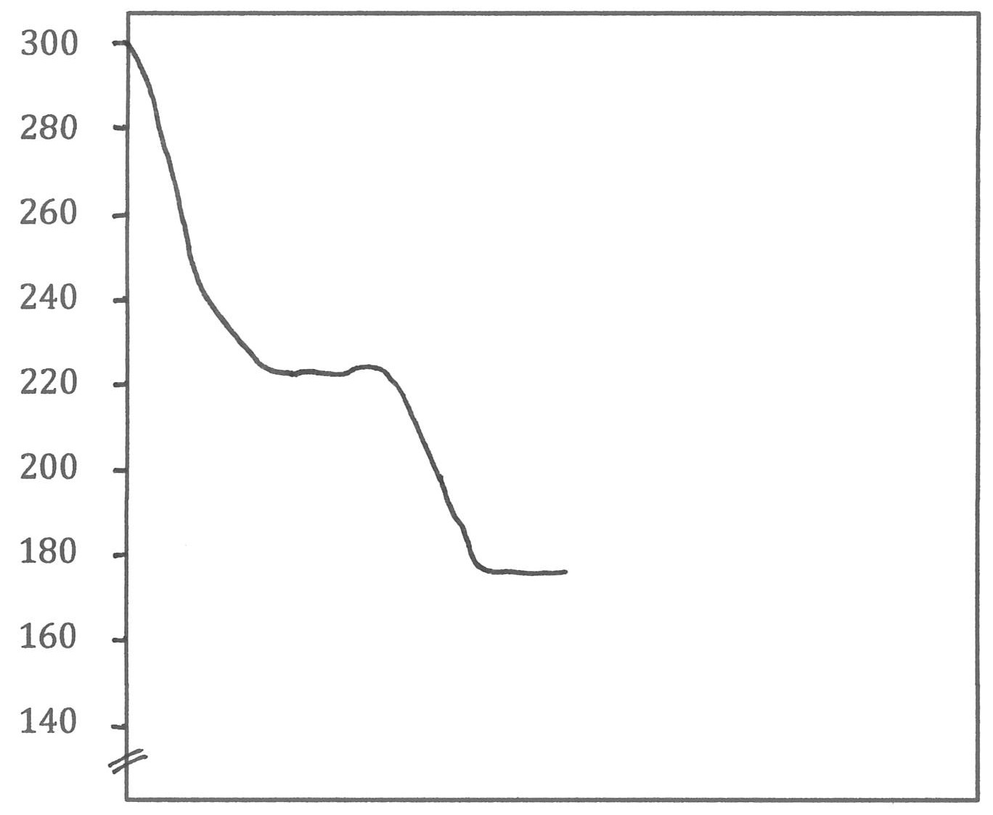

1. On your completed cross section above, correctly annotate (label) the extent or location of the following features:
2. the area/s of dense forest
3. the drain
4. the vehicle track (3 marks)

**Question 22 (4 marks)**

Describe **two (2)** characteristics of the site and **two (2)** characteristics of the situation of the residential area of Riverside.

**Site characteristic 1:**

|  |
| --- |
|  |
|  |

**Site characteristic 2:**

|  |
| --- |
|  |
|  |

**Situation characteristic 1:**

|  |
| --- |
|  |
|  |

**Situation characteristic 2:**

|  |
| --- |
|  |
|  |

**Question 23 (2 marks)**

Calculate the average gradient of the slope between GR 031112 and GR 040116. Show both your method of calculation and your answer.

**Calculation:**

|  |
| --- |
|  |
|  |
|  |
|  |
|  |

**Answer:** ________________________________

**Question 24 (2 marks)**

If you were travelling along Route C734 at 95 km/h, between the intersection at GR 066144 and where this road meets the western border of the map at Easting 02, how many minutes would your journey take? Show both your method of calculation and your answer.

**Calculation:**

|  |
| --- |
|  |
|  |
|  |
|  |
|  |

**Answer:** ________________________________

Refer to **Source 1:** Launceston topographic map and **Source 2:** Launceston satellite image to answer Question 25.

**Question 25 (3 marks)**

Identify the dominant land use found in AR 1013 and AR 1014. Describe two pieces of evidence from **Source 1** and/or **Source 2** to suggest why this type of land use was originally located here.

**Landuse:** _______________________________________________________________

**Evidence 1:**

|  |
| --- |
|  |
|  |

**Evidence 2:**

|  |
| --- |
|  |
|  |

Refer to **Source 6** Factors influencing global integration to answer Question 26.

**Question 26 (6 marks)**

Describe how **three (3)** of the factors listed on **Source 6** have facilitated international integration.

First factor:

|  |
| --- |
|  |
|  |
|  |
|  |
|  |

Second factor:

|  |
| --- |
|  |
|  |
|  |
|  |
|  |

Third factor:

|  |
| --- |
|  |
|  |
|  |
|  |
|  |

**Question 27 (3 marks)**

Describe how the increased globalisation of production may lead to lower levels of sustainability.

|  |
| --- |
|  |
|  |
|  |
|  |
|  |
|  |
|  |
|  |
|  |

Refer to **Source 7:** 2018: This is what happens in an internet minute to answer Question 28.

**Question 28 (4 marks)**

Describe how emerging digital media platforms are enabling the process of international integration through the diffusion and adaptation of new ideas, shared meanings and elements of culture across the globe.

|  |
| --- |
|  |
|  |
|  |
|  |
|  |
|  |
|  |
|  |
|  |
|  |
|  |
|  |

Refer to **Source 8:** Global city power index to answer question 29.

**Question 29 (6 marks)**

Explain the economic and cultural importance of world cities, as demonstrated in **Source 8**, in the integrated global economy and their role as centres of cultural innovation.

|  |
| --- |
|  |
|  |
|  |
|  |
|  |
|  | |
|  | |
|  | |
|  | |
|  | |
|  | |
|  | |
|  | |
|  | |
|  | |
|  |
|  |
|  |

Refer to **Source 9:** The rise of east and south to answer question 30.

**Question 30 (4 marks)**

Clarify how the evidence of change, presented in **Source 9**, demonstrates the concept of global shifts with the re-emergence of Asia, particularly China and India, as global economic powers.

|  |
| --- |
|  |
|  |
|  |
|  |
|  |
|  |
|  |
|  |
|  |
|  |
|  |
|  |

**END OF SECTION TWO**

**Section Three: Extended response 40% [40 marks]**

This section contains **four (4)** questions. You must answer **two (2)** questions; **one (1)** from **Part A** and **one (1)** from **Part B**. Write your answers in this answer booklet or lined paper provided by your teacher/supervisor.

Additional working space pages for planning or continuing an answer are provided at the end of this Question/Answer booklet or provided by your teacher/supervisor. If you use these pages, indicate at the original answer, the page number it is planned/continued on and write the question number being planned/continued on the additional working space page.

Wherever possible, **relevant, fully labelled sketch maps, diagrams and actual examples** should be used to illustrate and support your answers.

Suggested working time for this section is 80 minutes

________________________________________________________________________

**PART A ― Depth Study 1**

**Answer either Question 31 or Question 32**

**Question 31 20 marks)**

1. Describe the nature of a commodity, good or service you have studied.

(8 marks)

1. Describe and explain the changes occurring in the spatial distribution of the production and consumption of the commodity, good or service you referred to in part (a), in Australia and overseas.

(12 marks)

**OR**

**Question 32 (20 marks)**

(a) Describe the process of diffusion and the spatial outcomes for a commodity, good or service you have studied.

(8 marks)

(b)Explain the role played by technological advances in transport and/or telecommunications in facilitating changes in the spatial distribution of the commodity, good or service you referred to in part (a).

(12 marks)

**PART B ― Depth Study 2**

**Answer either Question 33 or Question 34**

**Question 33 (20 marks)**

1. Describe the likely future changes in the nature and spatial distribution of an element of culture you have studied.

(8 marks)

1. Evaluate the role of the media and new technologies in shaping people’s perceptions of places and events through the images and information they present in relation to the element of culture you referred to in part (a).

(12 marks)

**OR**

**Question 34 (20 marks)**

1. Describe the role played by transnational institutions and/or corporations in the dispersion of an element of culture you have studied.

(8 marks)

1. Discuss the ways people and places embrace, adapt to or resist the forces of international cultural integration, in relation to the element of culture you referred to in part (a).

(12 marks)

**END OF SECTION THREE**

**END OF PAPER**

Question number:

|  |
| --- |
|  |
|  |
|  |
|  |
|  |
|  |
|  |
|  |
|  |
|  |
|  |
|  |
|  |
|  |
|  |
|  |
|  |
|  |
|  |
|  |
|  |
|  |
|  |
|  |
|  |
|  |
|  |

Question number:

|  |
| --- |
|  |
|  |
|  |
|  |
|  |
|  |
|  |
|  |
|  |
|  |
|  |
|  |
|  |
|  |
|  |
|  |
|  |
|  |
|  |
|  |
|  |
|  |
|  |
|  |
|  |
|  |
|  |
|  |
|  |

Question number:

|  |
| --- |
|  |
|  |
|  |
|  |
|  |
|  |
|  |
|  |
|  |
|  |
|  |
|  |
|  |
|  |
|  |
|  |
|  |
|  |
|  |
|  |
|  |
|  |
|  |
|  |
|  |
|  |
|  |
|  |
|  |
|  |

Question number:

|  |
| --- |
|  |
|  |
|  |
|  |
|  |
|  |
|  |
|  |
|  |
|  |
|  |
|  |
|  |
|  |
|  |
|  |
|  |
|  |
|  |
|  |
|  |
|  |
|  |
|  |
|  |
|  |
|  |
|  |
|  |

Question number:

|  |
| --- |
|  |
|  |
|  |
|  |
|  |
|  |
|  |
|  |
|  |
|  |
|  |
|  |
|  |
|  |
|  |
|  |
|  |
|  |
|  |
|  |
|  |
|  |
|  |
|  |
|  |
|  |
|  |
|  |
|  |
|  |

Question number:

|  |
| --- |
|  |
|  |
|  |
|  |
|  |
|  |
|  |
|  |
|  |
|  |
|  |
|  |
|  |
|  |
|  |
|  |
|  |
|  |
|  |
|  |
|  |
|  |
|  |
|  |
|  |
|  |
|  |
|  |
|  |

Question number:

|  |
| --- |
|  |
|  |
|  |
|  |
|  |
|  |
|  |
|  |
|  |
|  |
|  |
|  |
|  |
|  |
|  |
|  |
|  |
|  |
|  |
|  |
|  |
|  |
|  |
|  |
|  |
|  |
|  |
|  |
|  |
|  |

Question number:

|  |
| --- |
|  |
|  |
|  |
|  |
|  |
|  |
|  |
|  |
|  |
|  |
|  |
|  |
|  |
|  |
|  |
|  |
|  |
|  |
|  |
|  |
|  |
|  |
|  |
|  |
|  |
|  |
|  |
|  |
|  |

Question number:

|  |
| --- |
|  |
|  |
|  |
|  |
|  |
|  |
|  |
|  |
|  |
|  |
|  |
|  |
|  |
|  |
|  |
|  |
|  |
|  |
|  |
|  |
|  |
|  |
|  |
|  |
|  |
|  |
|  |
|  |
|  |
|  |

Question number:

|  |
| --- |
|  |
|  |
|  |
|  |
|  |
|  |
|  |
|  |
|  |
|  |
|  |
|  |
|  |
|  |
|  |
|  |
|  |
|  |
|  |
|  |
|  |
|  |
|  |
|  |
|  |
|  |
|  |
|  |
|  |

Question number:

|  |
| --- |
|  |
|  |
|  |
|  |
|  |
|  |
|  |
|  |
|  |
|  |
|  |
|  |
|  |
|  |
|  |
|  |
|  |
|  |
|  |
|  |
|  |
|  |
|  |
|  |
|  |
|  |
|  |
|  |
|  |
|  |